Experiment 7

Aim: Study the use of network reconnaissance tools and apply the following: WHOIS, dig, traceroute, nslookup.
Theory: -
Network reconnaissance involves collecting information about computer systems, networks,
or domains, often as a preliminary step in cybersecurity analysis or penetration testing. The
following tools are commonly used for gathering publicly accessible data.

1. ifconfig (Interface Configuration)
ifconfig is a network configuration command used to view and configure network interfaces on a system. It is commonly used in Unix/Linux systems to display information about network interfaces and to assign IP addresses or enable/disable interfaces.
What it reveals:
- IP address assigned to the interface
- MAC (hardware) address of the interface
- Network mask (subnet mask)
- Broadcast address
- Status of the network interface (up or down)
- Statistics such as packets sent/received and errors
Use Cases:
- Viewing network interface configuration
- Troubleshooting network connectivity issues
- Assigning or changing IP addresses manually
- Enabling or disabling network interfaces
- Monitoring network interface statistics
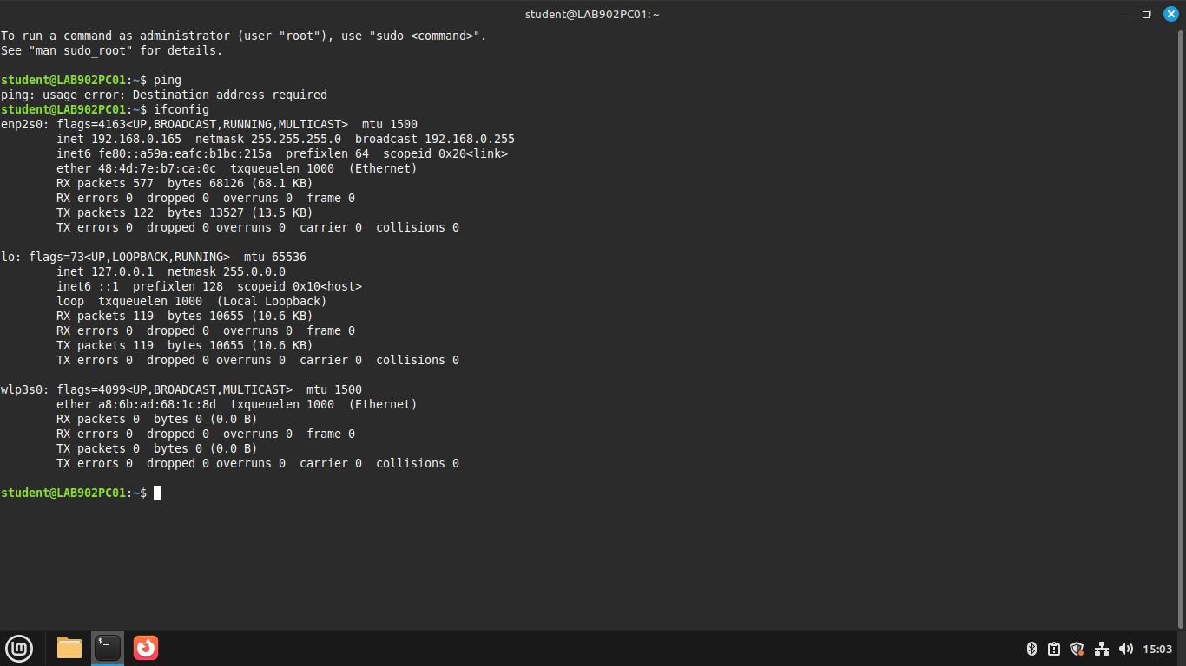

2. WHOIS
WHOIS is a query-response protocol used to obtain domain registration details
from a publicly accessible database.
What it reveals:
- Domain owner
- Registrar details
- Domain creation and expiration dates
- Contact information for the registrant, administrator, and technical personnel
- Name servers used by the domain
Use Cases:
- Identifying domain ownership
- Contacting domain administrators
- Verifying domain legitimacy
- Gathering information for legal or investigative purposes
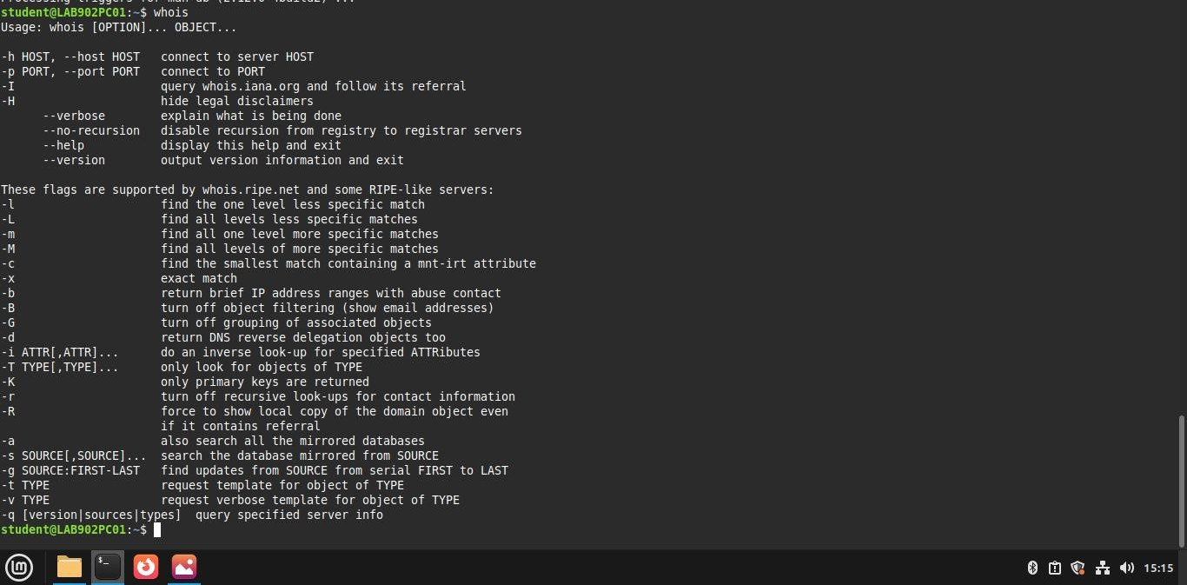
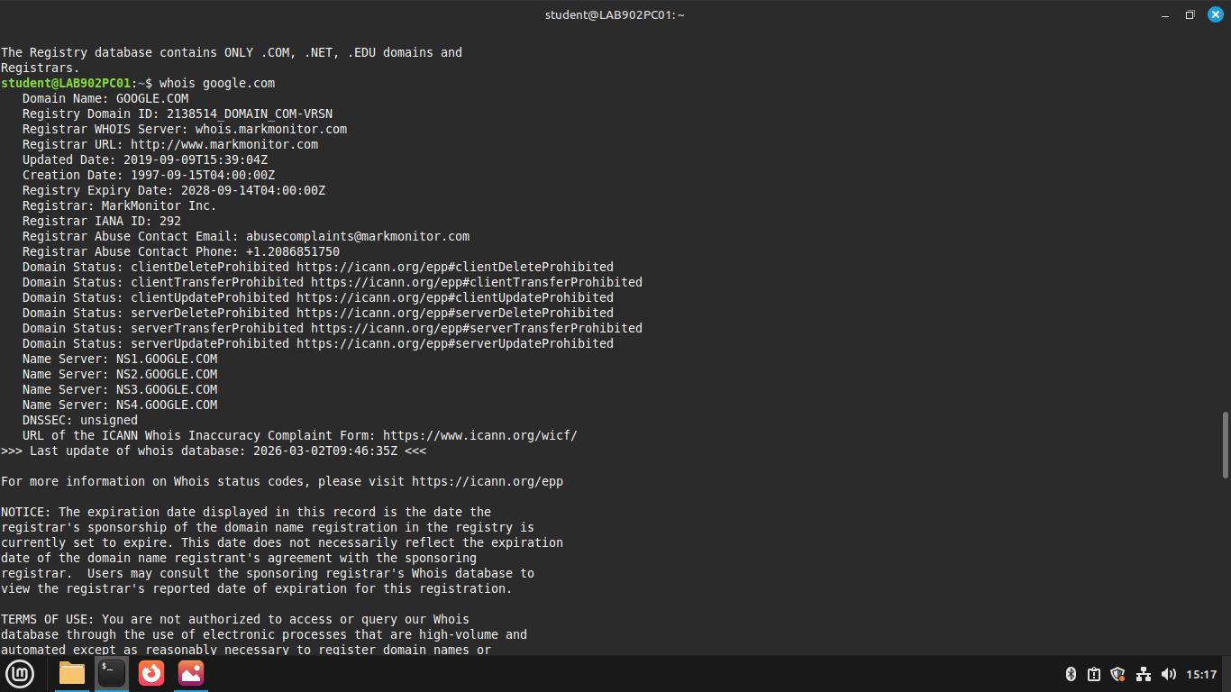
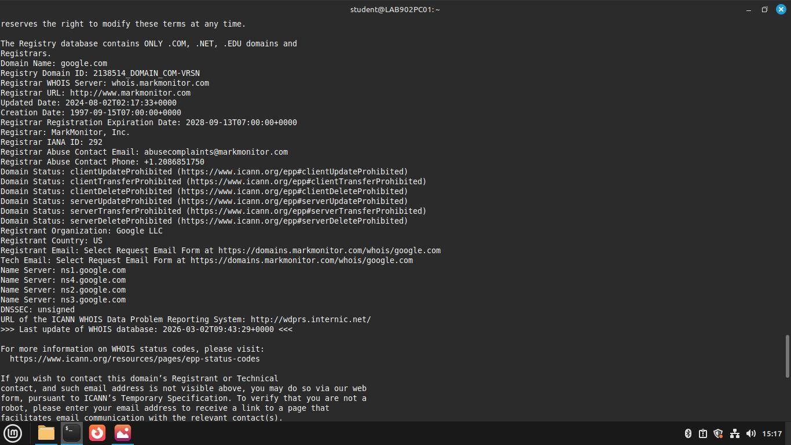
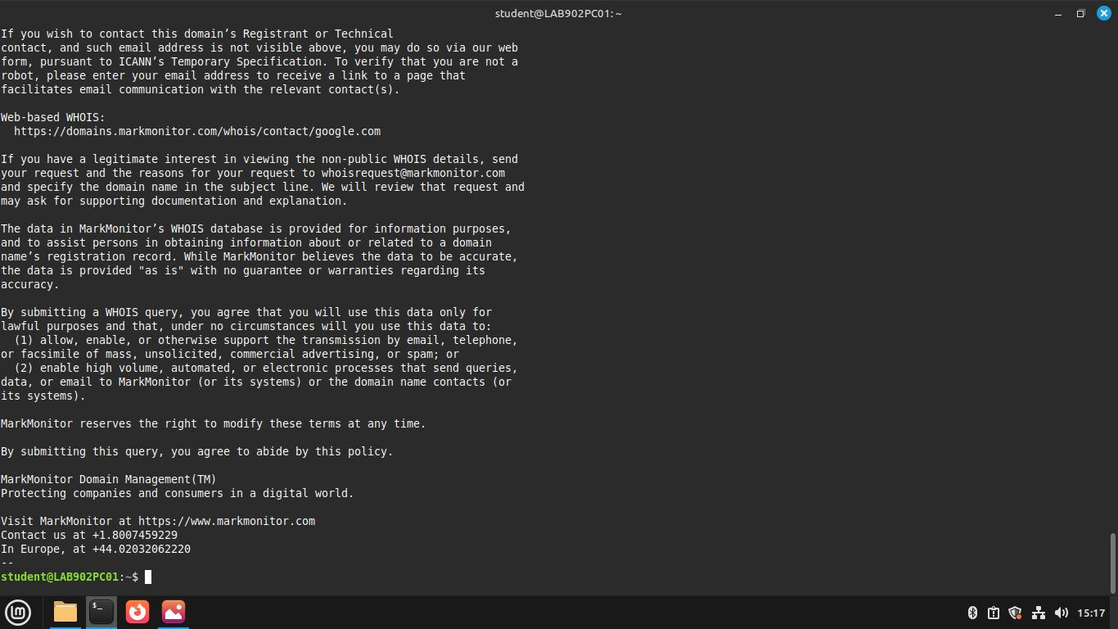

3. dig (Domain Information Groper)
dig is a DNS query tool used to retrieve information from name servers about
DNS records.
What it reveals:
- IP addresses of domain names
- Mail exchange (MX) records
- Name server (NS) records
- Other DNS record types such as TXT, CNAME, and SOA

Use Cases:
- Troubleshooting DNS-related issues
- Inspecting DNS configuration and records
- Verifying domain resolution and propagation
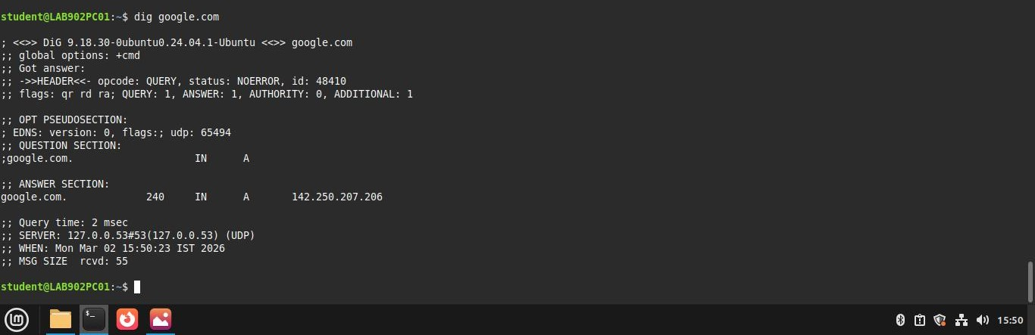
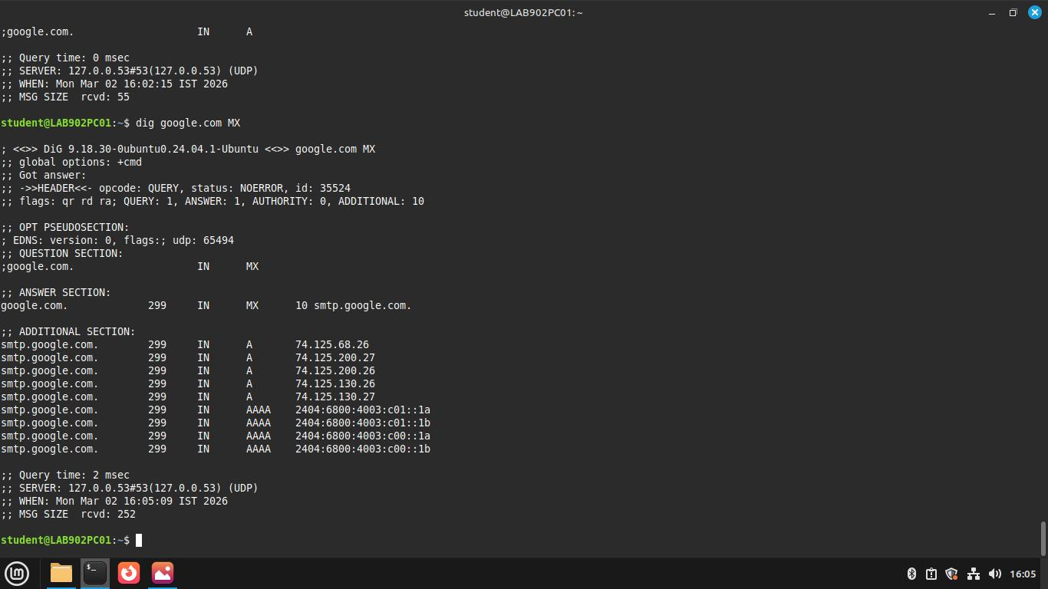
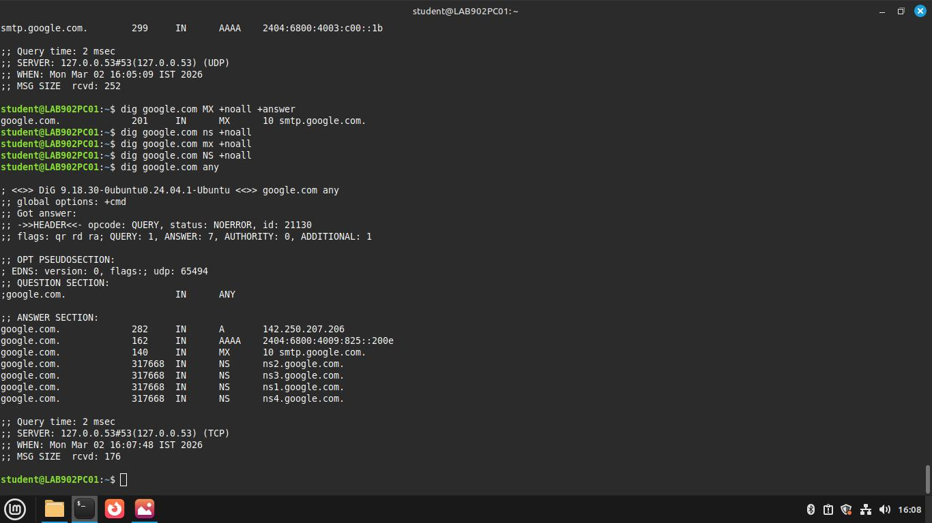
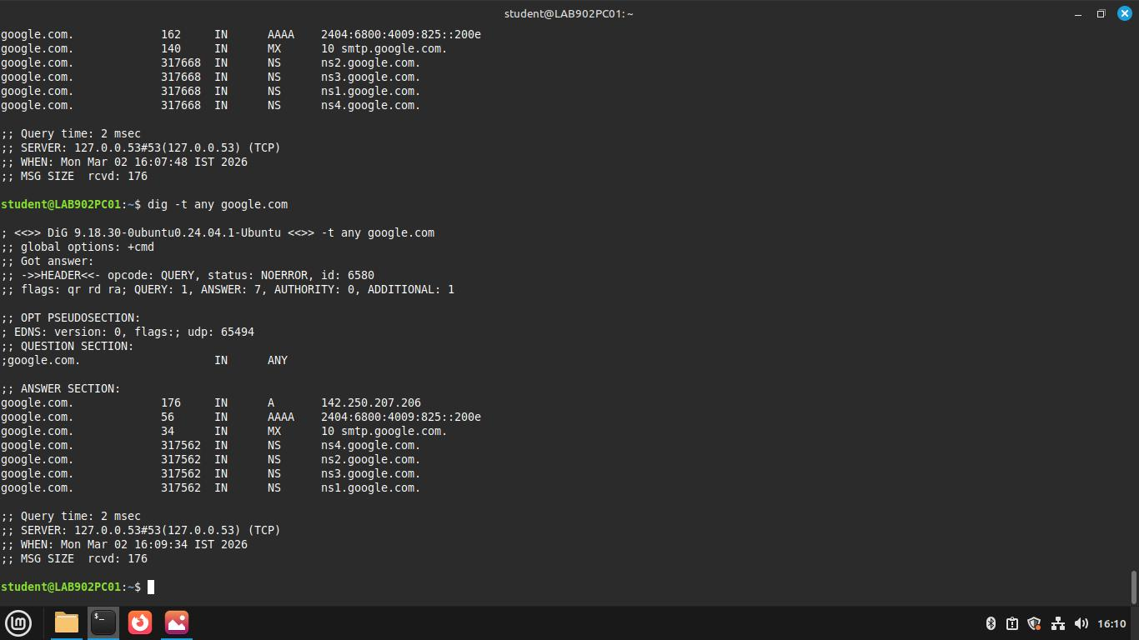
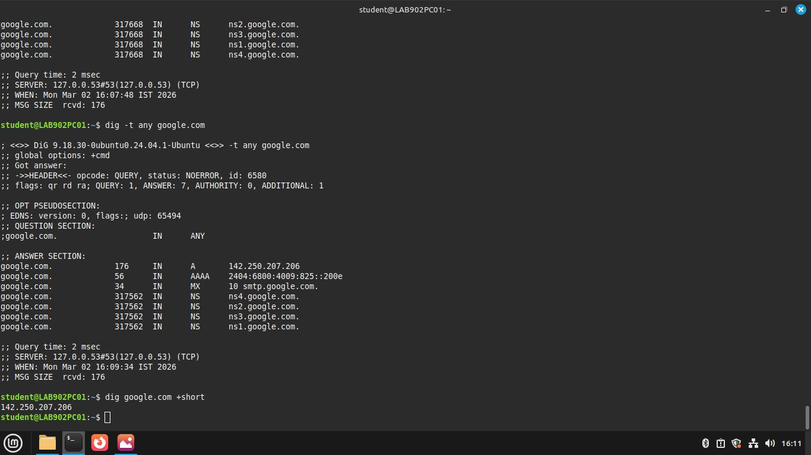

4. traceroute
traceroute is a network diagnostic tool used to display the route and transit
delays of packets across an IP network from source to destination.
What it reveals:
- The sequence of routers (hops) data packets pass through
- IP addresses of intermediate hops
- Round-trip time to each hop
Use Cases:
- Network troubleshooting
- Identifying routing problems
- Analyzing latency or packet loss issues
- Mapping network paths
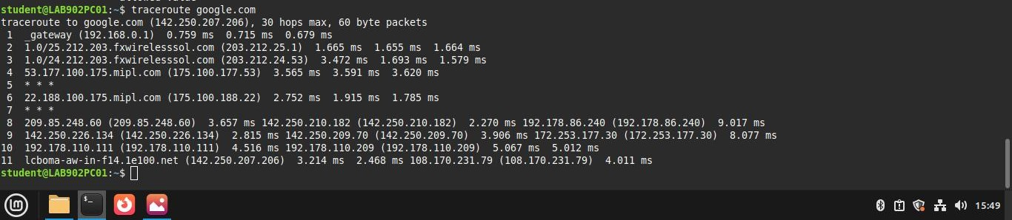

5. nslookup
nslookup is a network administration command-line tool used to query DNS
servers and obtain domain-related information.
What it reveals:
- IP addresses associated with domain names
- Specific DNS records such as MX, NS, and TXT
- Information about the DNS server being queried
Use Cases:
- Resolving hostnames to IP addresses
- Diagnosing DNS-related problems
- Retrieving DNS information for analysis
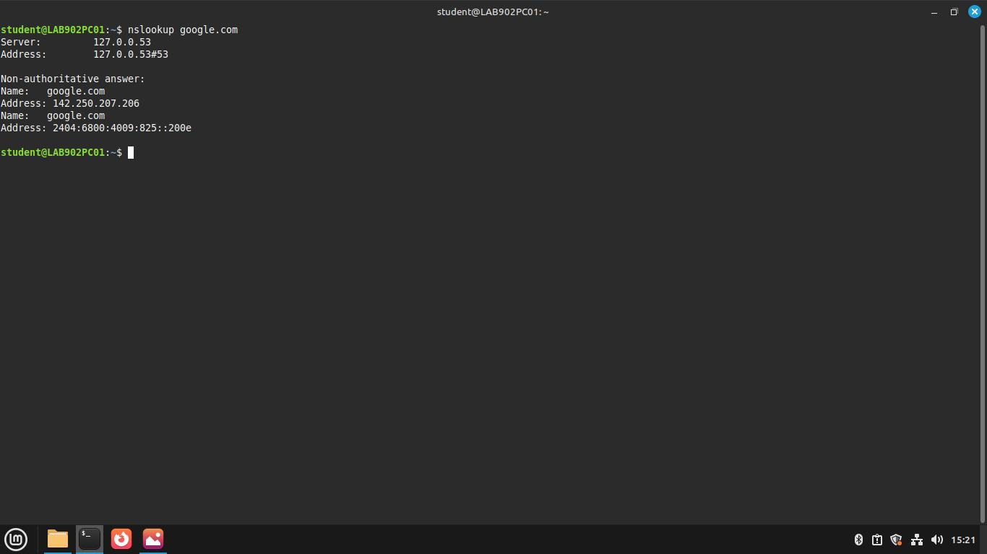
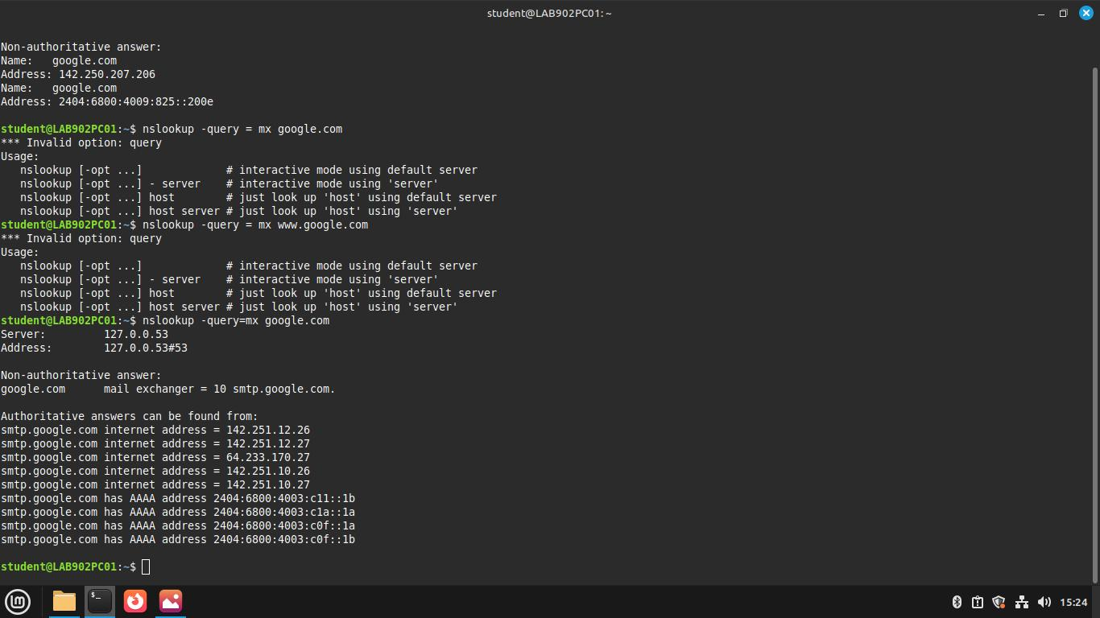
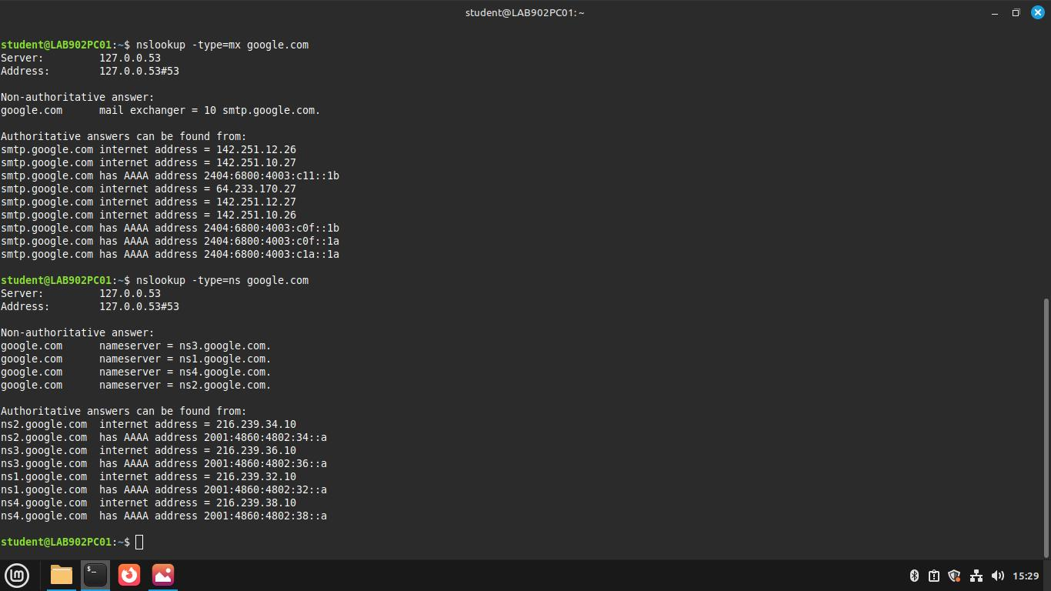
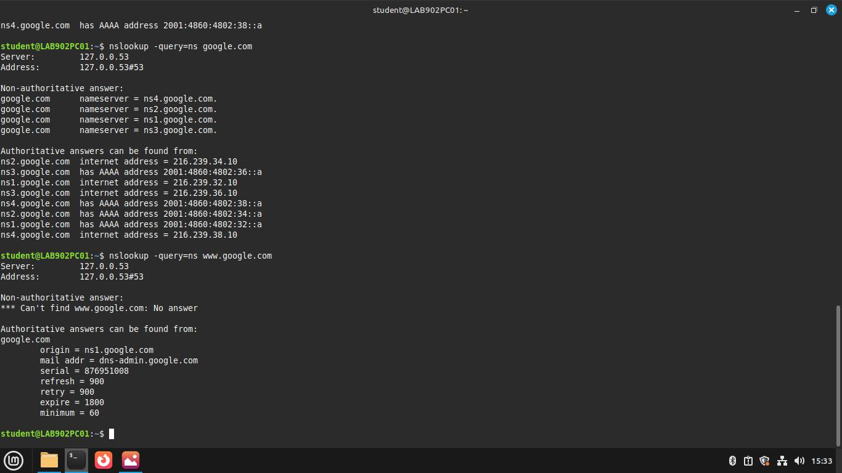
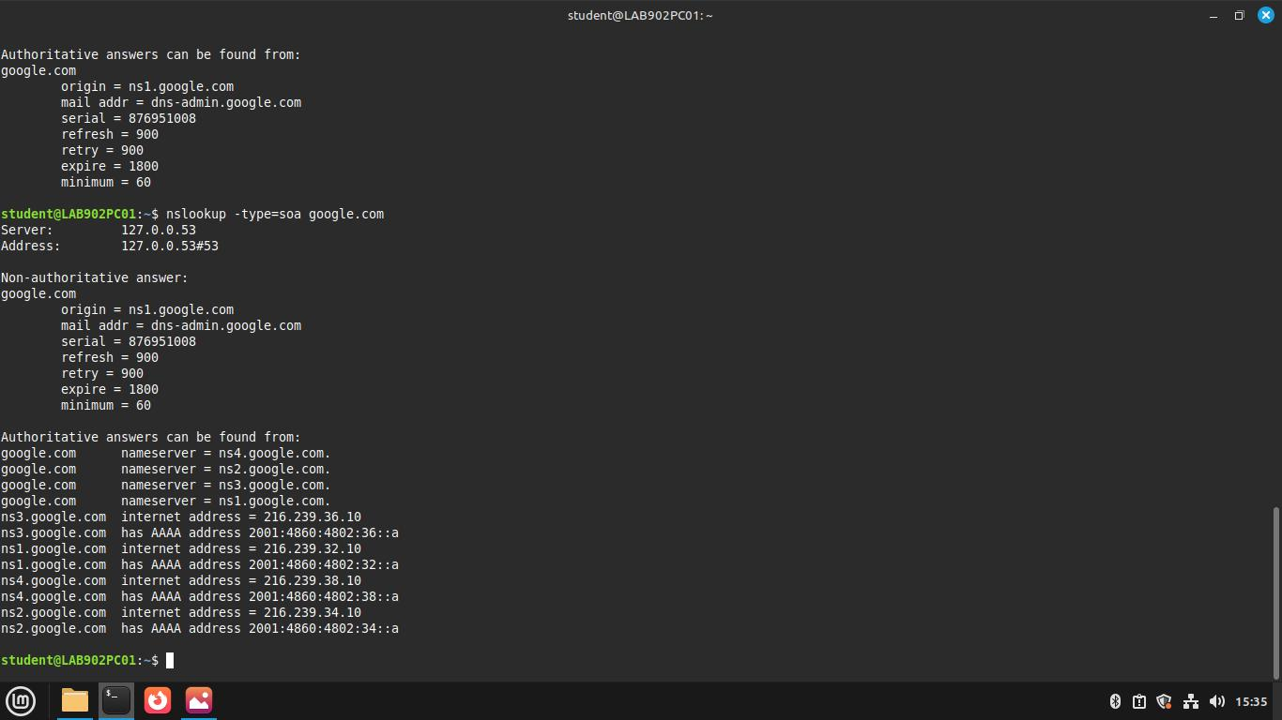
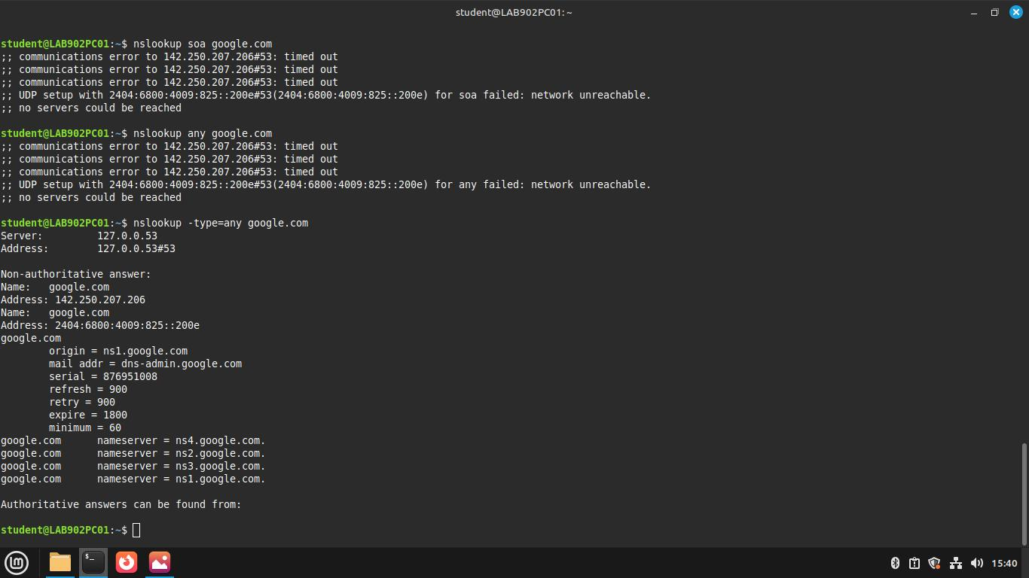

6. ping
ping is a network diagnostic tool used to test the reachability of a host on an IP network. It works by sending ICMP (Internet Control Message Protocol) Echo Request packets to the target host and waiting for Echo Reply responses.
What it reveals:
- Whether a host is reachable on the network
- Round-trip time (RTT) for packets between the source and destination
- Packet loss statistics
- IP address of the responding host
Use Cases:
- Checking network connectivity between two devices
- Testing whether a server or website is reachable
- Measuring network latency and response time
- Diagnosing packet loss or network delays
- Troubleshooting general network communication issues
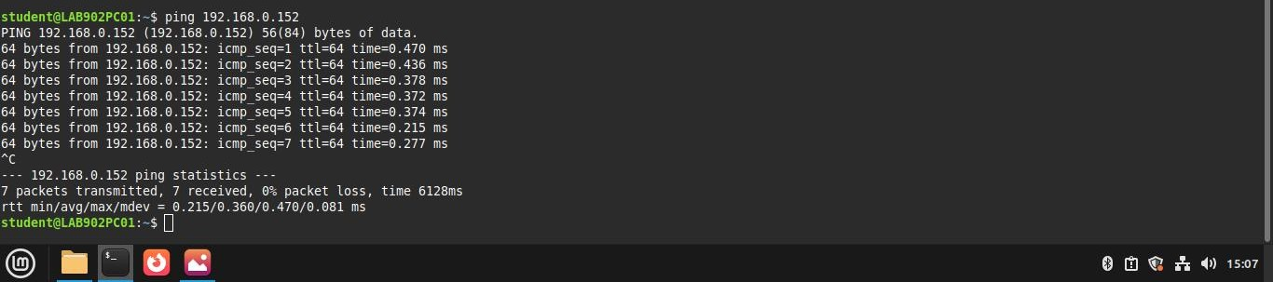

7. netstat (Network Statistics)
netstat is a command-line network utility used to display active network connections, routing tables, interface statistics, and network protocol information on a system.
What it reveals:
- Active TCP and UDP connections
- Listening ports on the system
- IP addresses and port numbers of connected hosts
- Routing table information
- Network interface statistics
Use Cases:
- Monitoring active network connections
- Identifying open or listening ports on a system
- Troubleshooting network connectivity issues
- Detecting suspicious or unauthorized network activity
- Analyzing network traffic and protocol statistics
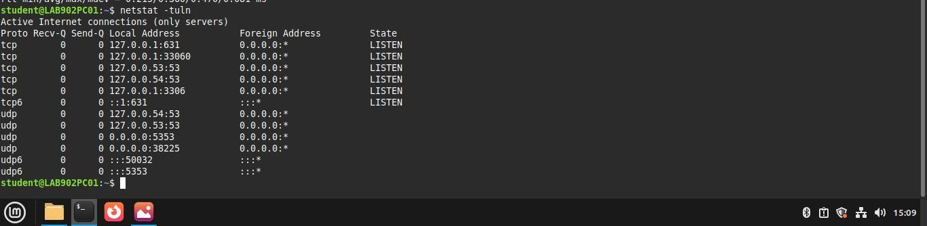

8. nmap (Network Mapper)
nmap is a network scanning and security auditing tool used to discover hosts and services on a computer network. It sends specially crafted packets to target systems and analyzes the responses to determine information about the network.
What it reveals:
- Active hosts on a network
- Open, closed, or filtered ports
- Services running on those ports
- Operating system information of the target system
- Network topology and device details
Use Cases:
- Network discovery and mapping
- Identifying open ports and running services
- Security auditing and vulnerability assessment
- Detecting unauthorized devices on a network
- Evaluating network security and firewall configurations
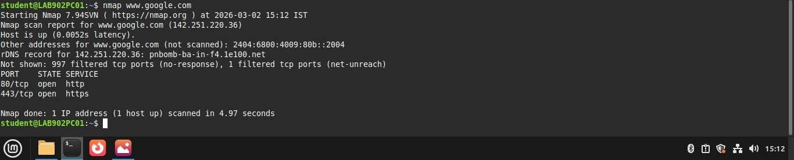

9. arp (Address Resolution Protocol)
arp is a network command used to display and modify the ARP cache, which maps IP addresses to MAC (Media Access Control) addresses within a local network.
What it reveals:
- Mapping of IP addresses to physical MAC addresses
- Devices currently communicating within the local network
- Entries stored in the ARP cache
- Interface associated with each ARP entry
Use Cases:
- Viewing the ARP table of a system
- Troubleshooting local network connectivity issues
- Identifying devices connected to the same network
- Detecting duplicate IP address conflicts
- Analyzing or managing ARP cache entries
